**FAMILY FITNESS APP FOR FAMILY HEALTH CLINIC**

Prepared by  
Huy Le, David Slusser, James Tack, Phong Vu, and Dennis Wu from M-Global, Inc

for

Dr. Romero Flores

Founder

Family Health Clinic

October 14, 2015

**CONTENTS**

**EXECTUTIVE** **SUMMARY**…………………………………………………………… 1

**INTRODUCTION** ………...…………………………………………………………… 2

Purpose  
 Product Description  
 Scope  
 Proposal Format

**FAMILY FITNESS APP: HOW IT WILL WORK** .………………………………….. 3

Development Overview  
How the Product Works  
Design  
Programming  
Testing  
Security  
Completion Time

**SUPPORT AND WARRANTY** ………...………………………………..………………. 5

Training  
Support  
Warranty  
Liability

**COST REDUCTIONS USING FAMILY FITNESS APP** …….……………….…….… 6

Google Cloud  
 Family Fitness App Charge  
 Extended Warranty

**CONCLUSION** …………………..………………………………………………………. 7

**APPENDICES** ……………………..……………………………………………..……...… 8

**EXECTUIVE SUMMARY**

Thanks to the advancement of medical technology, human beings are able to live much longer than compared to the past. With the increased population, there has always been a demand for more doctors and nurses. Having to deal with so many patients, medical staff can only go as fast as they humanly can without any mistakes.

Keeping track of patient information all at once can be very time-consuming, especially if the data is not all in one place. M-Global offers a mobile friendly application that can collect workout data from the patients and can then be monitored both by the staff and the patient themselves. The Family Fitness App will allow the patient to record their exercise data and store the information to Google Cloud as database storage. The information collected can then be monitored by the medical staff, allowing the medical center to view patients’ exercise patterns, and be able to keep track of their performance.

Because the Family Fitness App can collect and share the data to both the client and medical staff in a centralized and organized fashion, we believe that this can be a source of cost reductions for both the medical center and the patients. The medical staff can monitor and analyze the patient exercise data in real time and will be able to get a better understanding to help improve the patient’s health status.

**INTRODUCTION**

**Purpose**  
M-Global, Inc., will custom design and develop a distinct user friendly mobile application with state of the art mobile features designed to increase the interaction between patients and physicians at Family Health Clinic. This introduction describes the project site, scope and format for this report.

**Product Description**

This project is to provide a user friendly mobile application that involves collecting workout exercise data from devices that are connected to personal communication networks, which in turn can be connected to the Internet. It provides a dynamic and engaging experience for the mobile user that may help people live healthier and achieve more by tracking their heart rate, exercise, calorie burn, and sleep quality.

**Scope**

The purpose of this project is to respond to Dr. Flores of Family Health Clinic to fulfill all of their requirements for its ongoing success. This proposal reflects our thorough research and more than twenty years’ experience in creating mobile applications

**Proposal Format**

This report includes four main sections:

1. Application Specification: A complete discussion of how the application works, designing and developing, programming, and projected completion time.
2. Maintenance and Support: Describing the main tasks need to perform to prepare application for release, training, and security.
3. Costs: Summarizing the cost to build this mobile application.
4. Conclusion

**FAMILY FITNESS APP: HOW IT WILL WORK**

**How the Product Works**Instead of creating a full-fledged application, we will implement a web-application that is easily accessed from a web page or a simple application that will be available in the app store of every major application ecosystem. These include Apple’s App Store, Google’s Play Store and Microsoft’s Windows store.

All of the data associated with these services will be stored on a cloud based server. This provides two distinct advantages. The patient’s computer/mobile device will not have to do any of the computing when it comes to performing operations on data. The data will be accessible from any device and will not be lost if a device is damaged or lost.

**Development Overview**The development of this service will consist of three phases in order to maintain a clear and logical workflow. These phases include, in chronological order, design, programming and testing. The phases will be cyclical so that we can utilize our findings from the testing phase.

We will use a minimalistic design which incorporates tabbed sections for different categories of service and drop-down menus for inputting exercise data, as seen in Figure 1. A menu based interface creates a “multiple choice” user experience which will help users avoid formatting errors. For example, instead of asking a patient to input a date in mm/dd/yyyy format, a clickable calendar will be presented to the user when he or she selects the date input parameter.

**Design**The first of three services available will be a form to update exercise data. On the “Enter Exercise” tab, the patient will find a menu that includes a list of types of exercise which he or she can select from. If the patient’s exercise is not found, there is an option called “other”, which will then prompt an input field for the user to manually type in an exercise name. The patient will then be able to enter their duration of their exercise.

The next tab is a history of exercises that have been uploaded by the patient. We will employ a database that is searchable by both the patient and the medical staff. Search parameters will be provided in a menu that will include date, exercise-type and duration.

The final tab is named, “groups” and contains options for sharing your status updates on third party sites such as Facebook, Twitter and Instagram. The “Groups” tab will be essential for continued use, since it will create a social aspect of the program that will drive patients to maintain their updates. No data will be shared without being allowed by the patient first.

**Programming**Programming will take place after the design phase. Our programmers will begin to build the web application itself first and then move on to the remaining functions which will be used to access the web application. The final phase of programming will be dependent on our testing phase and will run concurrently.

**Testing**Testing will be split into two sections, which we will call Alpha and Beta. Alpha will be the pre-released testing that will be done by the programmers. They will stress-test and try to find problems. When we have achieved a problem-free version, we will pass it along to as a Beta release, which is the version that will be tested by the medical center employees.

**Security**  
We understand that data security is very important, especially in the medical field. We have chosen Google Cloud as the storage provider because they are Cloud certified in security. They undergo independent third party audits regularly and comply with top security certificates. Google has over 15 years in experience with popular applications such as Gmail and Google Apps, by using Google Cloud, we too can benefit from the same security model. All the data collected and stored in the cloud will be encrypted and also protected by the Google firewall.

**Completion Time**  
Figure 2 lists the maximum completion time for each phase. The application will be completed within a two month time frame.

There will be six phases of development; design, programming, Alpha testing, Beta testing, soft launch and release. Design will take approximately one week to finalize. The main part of programming is scheduled to take two weeks, after which we will move to Alpha testing. During Alpha testing, programming will continue but with more focus on debugging. After Alpha testing and debugging for a week, we will transition into the Beta testing. During this time, debugging will continue as we get feedback from the medical staff.

At the end of the seventh week, we will deploy a soft launch while eliminating any final bugs. The soft launch will be an unofficial release where we will enable all the features and let the medical center’s staff select a few patients to use the application. During this phase, our programmers will monitor and analyze all incoming and out coming data in real time. This will ensure that the actual launch will run smoothly.

A week after the soft launch, the application will be released to the public. Once in public hands, our priorities will switch primarily to post launch support; performing maintenance patching bugs, glitches, and as they appear.

**SUPPORT AND WARRANTY**

**Training**  
Once the Alpha version of the application is completed, we will be holding an orientation to train the health clinic employees on how to use the product. This service will be free of charge. Pamphlets with detailed descriptions/procedures will be distributed at the door before entering the orientation. We will instruct the employees step-by-step how to use the application which will allow them to demonstrate simple procedures to their patients how to use the supportive application.

The orientation will be recorded and can be distributed to any employees who didn't attend the orientation or would like to view the orientation again. During the first week of Beta launch, with your preference, an employee can be stationed at the clinic during two days of the week for five hours. This will allow employees to have hands on experience and questions answered immediately to maximize their knowledge of the application. The employees will be able to practice this exercise on each other until the official launch of the application.   
  
**Support**  
There will be customer contact services such as phone number for technical support (only for the health clinic employees) which allow employees to ask questions related to technical difficulties with the applications.

**Warranty**A free one year warranty will be included with the application. During the warranty period, M-Global will fix all software defects within the time limit provided the following conditions are met:

* proof that the failure occurred due to a development fault
* subject of the client’s complaint is covered in the requirements specification
* no unwarranted interference with the software package on the part of the client

After the release of the application, there will be a maintenance fee over the course of use.

**Liability**  
All of the data will be stored in the Google Cloud’s server. In an unlikely event that the server will crash, Google Cloud will automatically switch all of the data over to another server. We will also setup an automatic back up of the data periodically. All of the data will be encrypted and will be protected by the Google firewall. M-Global will only be liable for the website/application performance.

**COST REDUCTIONS USING FAMILY FITNESS APP**

Using the Family Fitness App will increase the efficiently of client data monitoring, and will help reduce the cost of future medical expenses for the clients. The application will decrease the amount of time medical staff spend sorting through data and thus result in more time for the staff to focus on the client at hand.

**Google Cloud**  
Table 1 lists the features that the Google Cloud storage service provides. The cost of using Google Cloud includes core cloud features and management such as Web Interface, Image Upload/Download from their server, Encrypted storage and Firewall, and Automatic Backup snapshot and Storage is estimated to be $1,483.07 per year. The package also includes a reasonable sized cloud storage and processor power.

**Family Fitness App Charge**  
The table below lists the charges for developing the application. These costs are a one-time charge and include the standard one year support as well. The entire application will be done in house at M-Global.

|  |  |
| --- | --- |
| **Cost of Family Fitness App** |  |
| **Services** | **Cost** |
| Design | $4,000 |
| Programming | $20,000 |
| Testing | $3,000 |
| Training | Free of charge |
| Maintenance and Basic Support | Free for first year |
| Security | Included with Google Cloud service |

**Extended Warranty**  
Aside from the standard one year of support and maintenance, M-Global will offer additional extended warranty packages. The price for each optional package is per year. All of the packages offer maintenance and bug fixes throughout the year. Each higher tier will include more support and a quicker response time.

|  |  |  |  |
| --- | --- | --- | --- |
| **Warranty Packages** |  |  |  |
|  | **Basic Package** | **Platinum Package** | **Titanium Package** |
| Maintenance / Bug Fix | Yes | Yes | Yes |
| Phone Support | 3/Month | Unlimited | Unlimited |
| Fastest Response Time | < 2 hours | < 1 hour | < 15 minutes |
| Priority Handling |  | Yes | Yes |
| Onsite Services |  |  | Yes |
| **Cost** | **$1,700** | **$2,500** | **$3,500** |

**CONCLUSION**

The Family Fitness App is a user friendly mobile application that will provide the Family Health Clinic an easy and efficient way to monitor their patients’ exercises patterns performed at various workout sites. Thus using this application, the Family Health Clinic can easily record and access accurate data representing their patients exercise habits.

It will also help the patient to keep track of their performance such as distance walked or run, calorie consumption, heart beat and quality of sleep that will synchronize the user’s device with Family Health Clinic and their associates as well as social media.

For the contemplation of Dr. Flores’s Family Health Clinic, who is very concerned about the wellbeing of his patients. M-Global will release this activity application in the two month’s timeline and will contribute greatly to the effectiveness, persona, and professionalism of the physicians at the Family Health Clinic.

We believe that the application will bring many benefits to Family Health Clinic, as well as their patients, not only to helps people live healthier and achieve more but also to connect to partner organizations such as healthcare professionals, health clubs, medical insurance companies, employers, etc. to achieve health cost reductions.

**APPENDICES**

Figure 1: Design Mock-Up

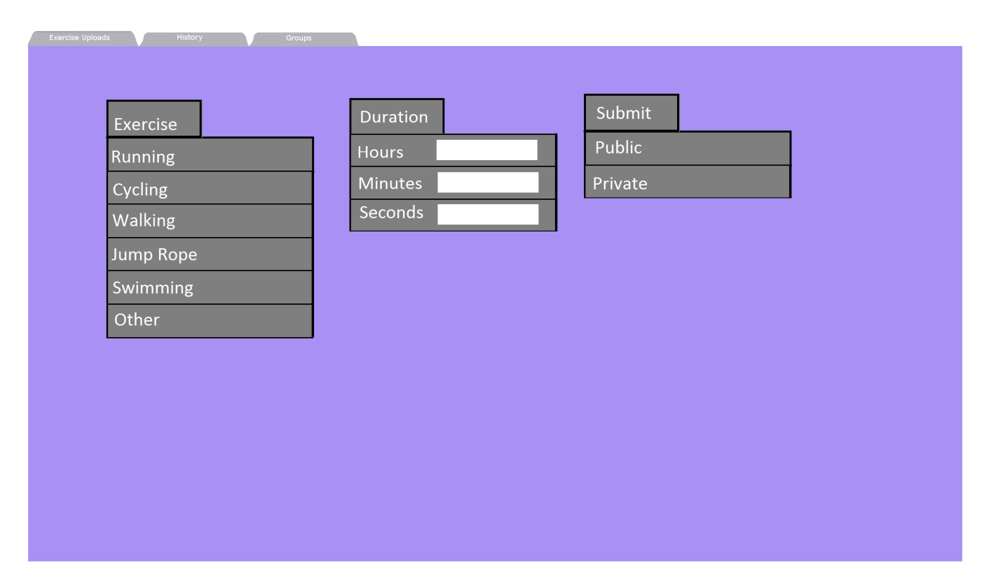

Design

Programming

Alpha Testing

Beta Testing

Soft Launch

Release

Post Launch

Week 1

Week 3

Week 4

Week 7

Week 8

Figure 2: Project Timeline

Table 1: Google Cloud

|  |  |  |  |
| --- | --- | --- | --- |
| **Features** | **Management** | **Security** | **Reliability** |
| Windows OS | Image Upload/Download from Cloud Server | Encrypted Storage | Support Response Time: 1 hour |
| CPU: 8x / vCPU: 16x | Resource Usage Monitoring Tool | Firewall & Certified Cloud Security Compliant | Phone Support |
| Storage: 1,000 Gb | Web Interface | Automatic Failover (switches server in case of failure) |  |
| RAM: 60 Gb |  | Backup Snapshot and Storage |  |